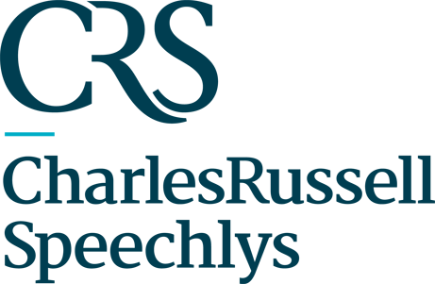 | Company: Charles Russell Speechlys SCS  Description: Our Luxembourg office neatly integrates the financial services, corporate, investment management and tax structuring capabilities for which it has built up a reputation.  Our Luxembourg team regularly advises financial institutions and corporate borrowers on secured lending transactions and cross-border collateral issues in acquisitions and real estate finance projects. We provide advice in connection with debt securities offerings, public offers, and stock exchange listings, as well as the regulatory aspects of the setting up of funds and regulated financial services business.  Lawyers in Luxembourg and London advise on the structuring, formation, marketing, and on-going operation of various types of investment vehicles (SIF, SICAR, UCI, UCITS, unregulated funds, securitisation vehicle) having all kind of investment strategies (from long only to private equity, real estate, hedge funds, SRI). Acting for a broad range of asset managers, our specialist funds, tax, and regulatory lawyers combine their skills to deliver tailor-made solutions embracing all aspects of a project.  Our Luxembourg dedicated litigation team represents a broad client base ranging from banks, investors, and multinationals to small and midsized enterprises as well as individuals in all levels of the Luxembourg commercial and civil courts. It assists in legal proceedings as well as out of court settlements with regards to business, finance, and employment law related disputes.  Contact: Cécile Bencetti  Address: 2 rue Jean Monnet, L-2180 Luxembourg  Tel: 26 48 68 36  E-mail: cecile.bencetti@crsblaw.com
We are currently looking for a

Legal Secretary (m/f)

As Legal Secretary your role is to provide administrative and organisational support to the partners and the other lawyers of the firm.

Your mission:

- Welcome visitors and clients in person or on the telephone
- Responsible for answering the telephone and directing phone calls
- Drafting e-mails as well as typing and posting of correspondence
- Assist in travel arrangements (flights, hotel, restaurant, taxis)
- Booking of meeting rooms, prepare relevant documentation for the meetings and coordinate client events
- Assist in the billing process of the firm and follow-up up on outgoing and incoming invoices
- Maintain databases and filing systems
- Assistance with regards to maintenance of the firm’s legal library
- Order and deposit of documents to the Luxembourg trade register
- Collecting and handling KYC documents
- Interact with the relevant administrative departments of the London office.

Your profile:

- Degree in secretarial work
- At least 2 to 3 years of secretarial experience within an international environment or a law firm in Luxembourg
- Self-motivated, proactive, and highly professional with ability to take on responsibility
- Fast and accurate typing skills with attention to detail
- Proficient in Word/Excel/ PowerPoint/Outlook
- Administrative and document management experience
- Superior organisational skills
- Be fluent in English and French (in writing and speaking). The knowledge of German and/or Luxembourgish will be considered as an asset
- Reliable, dynamic, team-spirit and trustworthy
- Working hours: 9am until 6 pm - Flexibility with regards to the starting hours and lunch break

Submit application:

Candidates may submit their application containing a letter of introduction and a resume online or by post or e-mail to Ms Cécile Bencetti at the above-mentioned address. Only candidates who are confident to meet the requirements set out above should apply.

